Example No 01
Input:
using System;

namespace Abdullah_Sadiq_CP_Lab_04
{
class Program
{
static void Main(string[] args)
{
int a = 5, b = 4;
Console.WriteLine("The value of a+b is\t:{0}", a + b);
Console.WriteLine("The value of a+(b++) is\t:{0}", a + (b++));
Console.WriteLine("The value of a+b is\t:{0}", a + b);
Console.WriteLine("The value of a+(++b) is\t:{0}", a + (++b));
Console.WriteLine("The value of a+b is\t:{0}", a + b);
Console.WriteLine("The value of 14/a is\t:{0}", 14 / a);
Console.WriteLine("The value of 14%a is\t:{0}", 14 % a);
}
}
}
Output:
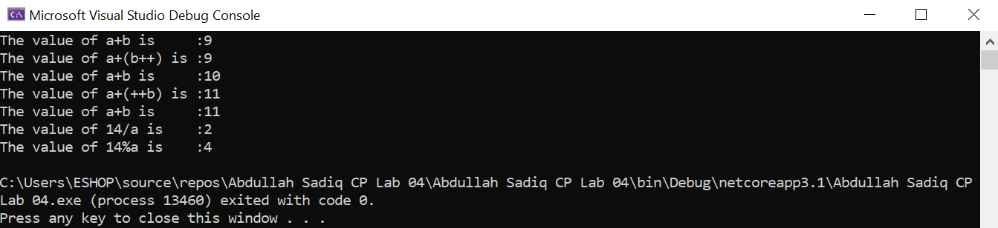
Example No 02
Input:
using System;

namespace Abdullah_Sadiq_CP_Lab_04
{
class Program
{
static void Main(string[] args)
{
bool a = true;
bool b = false;
Console.WriteLine(a && b);
Console.WriteLine(a || b);
Console.WriteLine(!b);
Console.WriteLine(b || true);
Console.WriteLine((5 > 7) ^ (a == b));
}
}
}
Output:
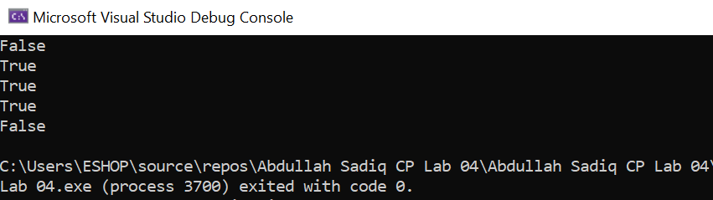
Example No 03
Input:
using System;

namespace Abdullah_Sadiq_CP_Lab_04
{
class Program
{
static void Main(string[] args)
{
int x = 10, y = 5;
Console.WriteLine("x>y:\t" + (x > y));
Console.WriteLine("x<y:\t" + (x < y));
Console.WriteLine("x>=y:\t" + (x >= y));
Console.WriteLine("x<=y:\t" + (x <= y));
Console.WriteLine("x==y:\t" + (x == y));
Console.WriteLine("x!=y:\t" + (x != y));
}
}
}
Output:
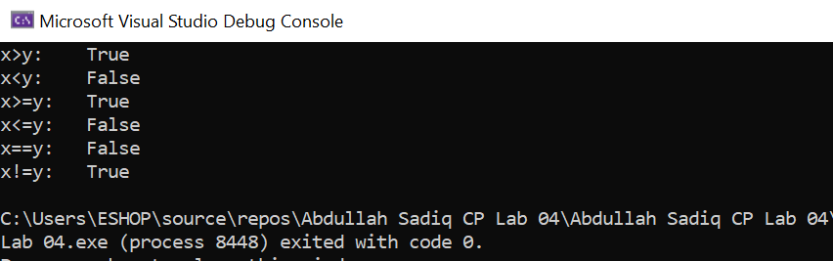
Task No 01: Which of the following values can be assigned to variables of type float, double and decimal:
5, -5.01, 34.567839023, 12.345, 8923.1234857, 3456.091124875956542151256683467
Solution:
- 5 = float
- -5.01 = float
- 34.567839023 = double
- 12.345 = float
- 8923.1234857 = double
- 3456.091124875956542151256683467 = decimal
Task No 02: Create a simple calculator which will perform all arithmetical, Bit wise operation and logical operation on two number.
Input:
int num1 = 123, num2 = 456;

Console.WriteLine("\tArithmatical Operators\n");
Console.WriteLine(" -Addition-");
Console.WriteLine("Sum of {0} and {1} is {2}", num1, num2, num1 + num2);
Console.WriteLine("\n -Subtraction-");
Console.WriteLine("Difference of {0} and {1} is {2}", num1, num2, num2 - num1);
Console.WriteLine("\n -Multiplication-");
Console.WriteLine("Product of {0} and {1} is {2}", num1, num2, num1 * num2);
Console.WriteLine("\n -Division-");
Console.WriteLine("Quotient of {0} and {1} is {2}", num1, num2, num2 / num1);
Console.WriteLine("\n -Module-");
Console.WriteLine("Modulus of {0} and {1} is {2}", num1, num2, num2 % num1);
Console.WriteLine("\n\n\tBit Wise Operators\n");
Console.WriteLine(" -And Operator-");
Console.WriteLine("Bit Wise AND Operator of {0} and {1} is {2}", num1, num2, num1 & num2);
Console.WriteLine("\n -OR Operator-");
Console.WriteLine("Bit Wise OR Operator of {0} and {1} is {2}", num1, num2, num1 | num2);
Console.WriteLine("\n -XOR Operator-");
Console.WriteLine("Bit Wise XOR Operator of {0} and {1} is {2}", num1, num2, num1 ^ num2);
Console.WriteLine("\n\n\tLogical Operator");
bool output;
//Or operator
output = (num1 == num2) || (num1 > 120);
Console.WriteLine(output);
output = (num1 == num2) && (num1 > 120);
Console.WriteLine(output);

Output:
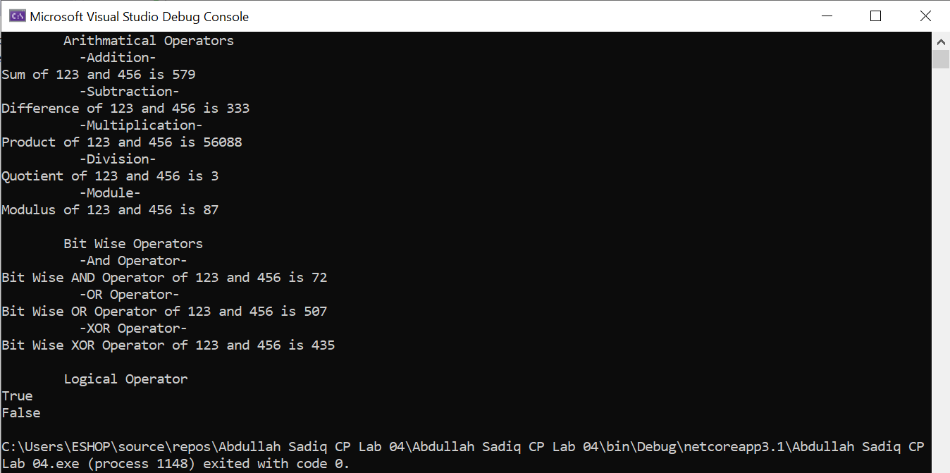
Task No 03: Create a simple program to calculate Hypotenuse using Pythagoras theorem c^2 =(a^2 + b^2)
Input:
using System;

namespace Abdullah_Sadiq_CP_Home_Tasks
{
class Program
{
static void Main(string[] args)
{
double hyp, side_a, side_b;
Console.WriteLine("\t-Calculate the Hypotanuse of a Right Angle Triangle-");
Console.WriteLine("\nEnter Lenght of Side 'A' (in cm):");
side_a = Convert.ToDouble(Console.ReadLine());
Console.WriteLine("Enter Lenght of Side 'B' (in cm):");
side_b = Convert.ToDouble(Console.ReadLine());
hyp = side_a*side_a + side_b*side_b;
double final_answer = Math.Sqrt(hyp);
Console.WriteLine("The Length of Hypotanuse is {0} cm", final_answer);
}
}
}
Output:
